## Annex 4 - Terms of Reference

## Master Facilitator – Youth Connect Jordan

**Programme:** Youth Connect-Jordan.

**Requirement:** One master facilitator in Jordan.

**Date of assignment:** April 2024- March 2025

**Background**

The British Council’s work in the area of Youth and Civil Society focuses on meeting the needs and aspirations of young people through programmes that support personal, social and economic development supporting young people to develop the skills, voice and agency to participate fully in, and shape, their societies. In MENA our work aims to address the effects on youth of political and economic instability. We focus on social impacts of high youth unemployment, increasing inequality and 10 years of polarisation. Our work empowers young women and men, especially those more marginalised, to contribute to more inclusive, effective governance, through opportunities to increase their skills and apply them; listen to, discuss, debate and collaborate with others including those with power; and lead real changes in their communities -- offline and online – which build increased resilience and social cohesion. Our work aims to increase young people’s sense of purpose, agency and stake in society, improve citizen-state and intergenerational relations, and build resilience against divisive narratives.

In Jordan, we are relaunching our Youth & Civil Society work under a new Global Youth and Civil Society British Council programme called *Youth Connect*. The programme is based on a bespoke learning journey, which will be developed in collaboration with the selected partners, and aims to deliver change at three levels:

* **Individuals**. Young people, women and girls and young people from disadvantaged or marginalised communities, will be provided with values-driven skills and learning opportunities. Skill areas to be offered include but are not limited to: critical thinking, problem solving, communications, negotiation, gender and equalities leadership, persuasion and influencing pedagogies. Each element has inclusivity, gender and diversity at its core.
* **Communities** Youth participants will be able to form positive collaborations and partnerships that guide them towards positive outcomes. We will provide tangible opportunities for young people, including women and girls and those from under-represented groups, to use their new skills to collaborate across divides and stimulate creative, positive contributions and solutions to local issues that matter to young people.
* **Institutional and policy level.** We will work with young people to advance their priorities to local and national stakeholders and duty bearers.

**Purpose of the project is:**

To strengthen civic engagement in Jordan at local community level by empowering a range of young people who, through collective action, can contribute to enhanced stability and community cohesion.

**Project Objectives:**

* To enhance the leadership capacities of young people and the values and principles which support inclusive, collaborative engagement. – especially young women and young people from marginalized groups – through a comprehensive skills development programme along with opportunities for capacity building and personal growth.
* To foster collaborative engagement between young people and key stakeholders in a way that enables collective action and addresses the priority concerns of Jordanian youth.
* To facilitate the co-design and implementation of collective action projects that respond to the priority concerns of Youth in Jordan and meet local community needs in conflict sensitive ways, ensuring they contribute to enhanced stability, community cohesion, and positive change.

**Project Learning Journey**

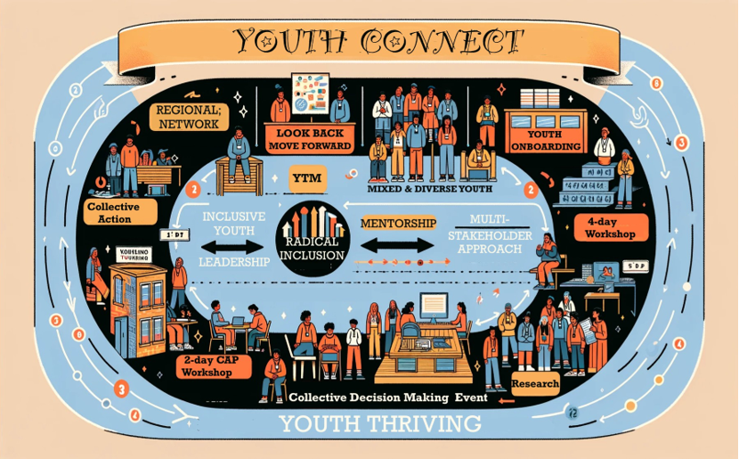

**Role Purpose**

The role mainly includes facilitating workshops, training facilitators and mentoring facilitators to effectively deliver ‘learning journeys’ with young people in the community. The post holder’s primary responsibility (and skillset) is to lead on and support the quality facilitation of workshops and learning journey’s for trainers and young people as part of the Youth Connect programme. In addition to this they will offer mentoring and support to local partners as they accompany young participants in the design and delivery of local action projects. The Master Facilitator will also report to and maintain a close working relationship with UK based consultants and a locally based network mentor.

The post holder will be working from home in Jordan with intermittent travel to other project and partner locations. S/he will work closely with Network members, British Council project team in country, and other UK based project stakeholders including the British Council UK team, MEL/Technical Advisor and trainers. S/he will report directly to the NFE project manager and the Head of Youth and Civil Society in Jordan.

The post holder is required to demonstrate advanced coaching /team facilitation skills and relevant experience as a local actor (mentoring by sharing her/his own experience), with excellent skills in relationship building for influence, mentoring, youth engagement and community development.

The focus of this recruitment is to support the facilitators from local partner organisations in training young people and to train young people in Jordan on soft skills and globally recognized skills, with the aim of strengthening civic engagement in Jordan at local community level by empowering a range of young people who, through collective action, can contribute to enhanced stability and community cohesion in line with the British Council’s youth programs.

The Master Facilitator will be responsible for developing and delivering training workshops on all the soft skills and globally recognized skills listed above, with a focus on the challenges and opportunities for youth in Jordan and in line with the organization's youth programs. The training workshops should be designed to be engaging and informative and should use a variety of teaching methods to meet the needs of all learners. The Master Facilitator is responsible for supporting the facilitators in designing, developing, and delivering training workshops to young people on soft skills and globally recognized skills, such as active listening, dialogue, community action project, collaborative and strategic thinking, problem-solving/critical thinking, research, economic mapping, policy engagement, digital skills and communications, leadership skills, human rights and democratic values, youth participation and agency, advocacy and network building, and socio-economic development, with a focus on the MENA region and the challenges and opportunities for youth in Jordan. The Master Facilitator will use a variety of teaching methods, including lectures, discussions, role-playing exercises, and case studies, to create an engaging and informative learning experience for participants.

**Main accountabilities**

**Facilitation, Mentorship and Coaching**

* Train and support/mentor new Youth Connect trainers who are identified by partners.
* Support British Council NFE staff in field activities to ensure joined up working with new trainers and overall approach.
* Co-facilitate the delivery of the Youth Connect training alongside a local facilitator from the local partner
* Mentor and coach the partner-identified facilitators to deliver a four day Collective Action Learning Journey in each location.
* Act as a local actor by applying skills, knowledge and sharing own experiences and best practices.
* Ensure effective liaison and maintain good communication between the partner identified facilitators, UK based consultants, the network mentor and the field coordinators who will support with monitoring and evaluation and project management in the community.

**Reporting and M&E support**

* Report information back to the management team to support feeding into the project monthly/quarterly progress reports
* Support development of lessons-learned and best practices
* Ensure proper and comprehensive documentation of the training activities, official communication, meeting minutes, and make sure all data and corresponding documentation is properly filed.

**Requirements:**

* Advanced coaching/team facilitation skills and relevant experience in mentorship.
* 6+ years’ experience in working on youth/community development programmes.
* Experience of working with vulnerable adults in less advantaged communities.
* Good understanding and proven experience engaging with and motivating hard-to-reach individuals/groups.
* Demonstrable knowledge of conflict sensitive programming, youth-centred approach to programme design, and participatory approach to community development.
* Ability to build effective relationships with internal and external partners and encourage an understanding of and sensitivity to youth development and youth vulnerability factors among community members and partners.
* Experience of working and building networks/relationships with government, civil society clients/partners, local Civil Society and youth groups.
* Ability to create impact, particularly with youth target audiences.
* Professional use of English language (minimum level: C1/B2).
* Very good written and oral communication skills in Arabic.
* Design, develop, and deliver training workshops on soft skills and globally recognized skills to young people in Jordan, with a focus on the challenges and opportunities for youth in the region, and in line with legacy progammes of the British Council in the space of youth and Civil Society programs, such as Young Mediterranean Voices, Strengthening Resilience (SR) , Tahawer, and Active Citizens.
* Use a variety of interactive and participatory teaching methods, including workshopping, discussions, role-playing exercises, and case studies, to create an engaging and informative learning experience for participants.
* Facilitate group discussions and activities to promote peer learning and collaboration.
* Create and maintain a positive and supportive learning environment.
* Provide feedback to programme leads, local partners, and trainers on their progress and development.
* Evaluate the effectiveness of training workshops and make necessary adjustments.
* Contribute to mentoring the young people’s learning journey in collaboration with the local partners and the British Council in Jordan.
* +6 years’ experience in adapting, developing and mentoring Youth learning journeys.
* Excellent organizational and time management skills.

The post holder will work on a daily-rate consultancy basis from home in Jordan with intermittent travel to other project and partner locations. At times when events are under development, may require working long and some out of work hours during evenings or over weekends responding to or driven by programme needs. Costs of travel and expenses will be agreed and claimed separately.

**Specific skills**

* Technical knowledge and/or experience of a sector relevant to the programme (e.g. Civil Society and Youth)
* Good use of relevant tools and techniques to inform programming including, vulnerability mapping, conflict analysis, power mapping, stakeholder analysis
* Facilitation skills working with participants and organisations from diverse backgrounds and sectors.
* Good communication and interpersonal skills capable of maintaining strong relationships
* Strong attention to detail and disciplined in reporting and meeting deadlines
* Self-motivated and self-managing, with the ability to manage under pressure
* Ability to develop strong team dynamics, understand and manage local dynamics and tensions
* Self-reliant and results-oriented
* Good report writing skills
* Strong organizational and multi-tasking skills
* Excellent analytical and problem-solving abilities.
* Soft skills: Active listening, dialogue, community action project, collaborative and strategic thinking, problem-solving/critical thinking.
* Globally recognized skills: Research, economic mapping, policy engagement, digital skills and communications, leadership skills, human rights and democratic values, youth participation and agency, advocacy and network building, socio-economic development.
* Very good experience in facilitating interactive workshops using a wide range of interactive facilitation tools and embedded learning methods.

**Desirable**

* Solid Knowledge of the Challenges and opportunities for youth in Jordan\ MENA region: Youth unemployment, lack of access to quality education, gender inequality, lack of political participation, climate change.
* Familiarity with the British Council’s youth programs: YMV, SR1 & SR2, Tahawer, Active Citizens, etc.

**Criteria and application procedure**

* **Refer to the Request For Proposal Form – RFP.**

**Applicants should submit a proposal including the following:**

* Annex 2 Supplier Response
* Annex 3 Pricing Approach